Angular

Error in Visual Studio:

ng.ps1 cannot be loaded because running scripts is disabled on this system

Solution :

Go to below path on your computer and delete the file as ng.ps1

C:\Users\Anil Kumar-DSPS\AppData\Roaming\npm

## Angular Components:-

Open your project editor and point the control src/app folder to make changes for the first component.  
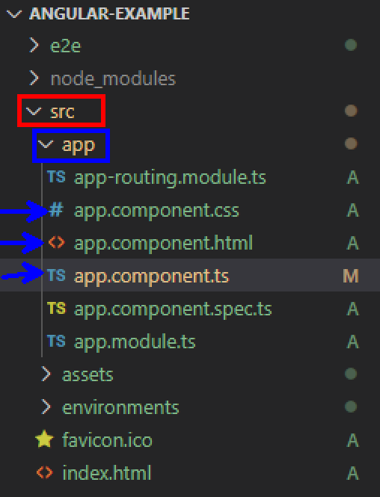

When we say component it consists of 3 files

1. App.component.ts - the component class code is written in typescript
2. App.component.html - the component template written in html
3. App.component.css - the component private CSS styles

Try to open the app.component.ts and change the title of it

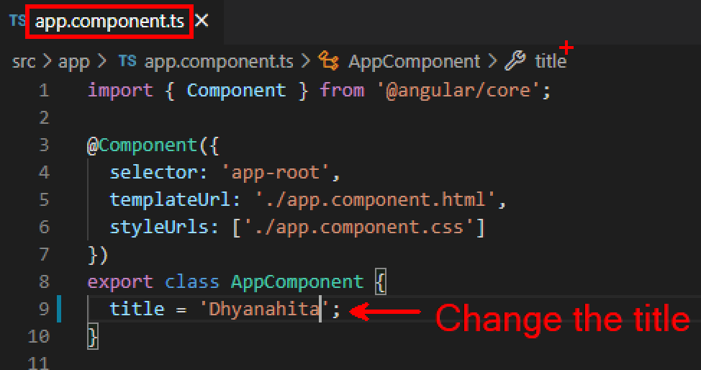

Just save the file automatically it auto refreshed on your browser

## Creating a new component in Angular project:

By using ng new component <ComponentName>

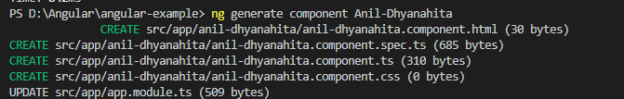

And try to change the .html,.css and .ts files, save it

